Chapter 4 Loops

**4.1 The While Loop**

* A loop executes instruction repeatedly while a condition is true
  + A while statement is an example of a loop
  + while (condition)

{

*Statements*

*}*

* When you create a variable *inside*  the loop body, the bariable is created for each iteration of the loop and **removed** after

**4.3 The For Loop**

* 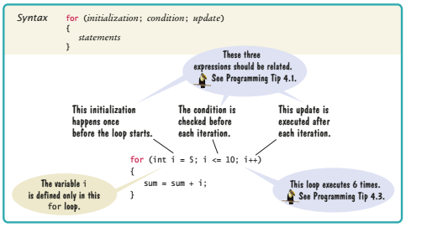
* If you declare a variable in the for brackets, then you can only use it for the loop

**4.4 The Do Loop**

* Do

**{**

*Statements*

}

while (*condition);*

* Condition is tested after so if the user enters something, if it is wrong it will keep doing this
  + Ex

Int value;

do{

System.out.print(“Enter an interger < 100: “);

value = in.nextInt();

}

While (value >= 100);

* + The program will now keep going till the user has entered an integer less than 100, because it will keep doing this till the integer is greater than or equal to 100

**4.5 Application : Processing Sentinel Values**

* A sentinel value denotes the end of a data set, but is not part of the data.
* Later

**4.10 Random Numbers and Simulations**

* Can call random numbers with
  + Math.random();
* The number will be between 0 and 1 including 0

**Other misc**

* 